This analytics model examines the relationship between historical Earnings Surprise and price movements around earnings announcement dates. The underlying assumption behind this study is that stock prices have priced in all available information and would respond to new information, such as earnings surprises resulting in “post earnings announcement drift”. For example, a positive earnings surprise should theoretically lead to a price rally, while an earnings miss is likely to trigger a sell-off.
The study is conducted on Bloomberg BQuant Desktop (Python), using the constituents of MSCI Asia Pacific ex Japan Index (MXAPJ Index) as the universe over a 10 year period (15-05-2015 to 15-05-2025). The goal of the study is to assess whether a positive or negative earnings surprises for stocks within the index are associated with an increase or decrease in stock price over the following 5 trading days after an earnings announcement. Earnings surprise is defined as follows:
$S= \frac{a-e}{e}$ 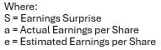
1Day Return [Including Outliers(ie. 1.5 IQR)]
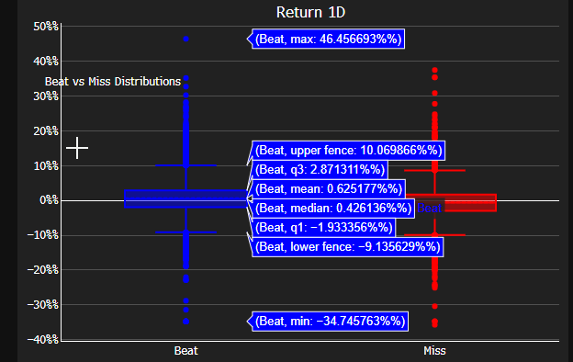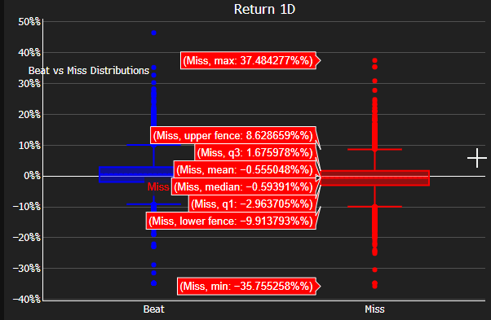
 |  | Day 1 | Day 2 | Day 3 | Day 4 | Day 5
Beat | Mean | 0.62% | 0.79% | 0.86% | 0.93% | 0.96%
Beat | Median | 0.42% | 0.49% | 0.55% | 0.63% | 0.58%
Miss | Mean | -0.55% | -0.64% | -0.64% | -0.62% | -0.55%
Miss | Median | -0.59% | -0.68% | 0.74% | -0.63% | -0.66%

1Day Return [Excluding Outliers(ie. 1.5 IQR)]
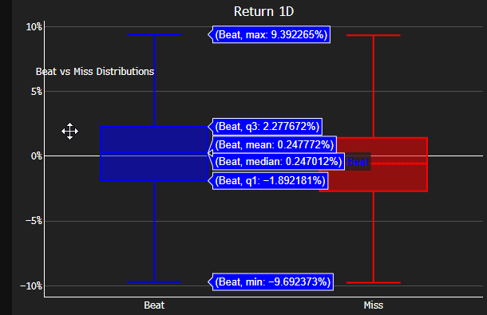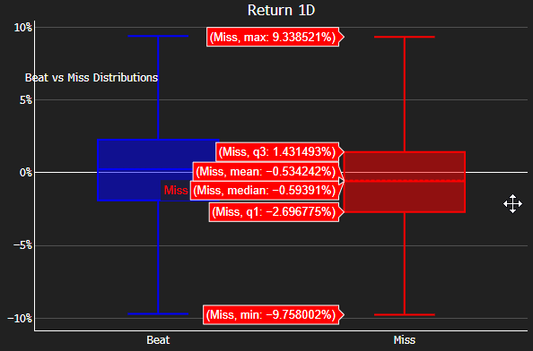
 |  | Day 1 | Day 2 | Day 3 | Day 4 | Day 5
Beat | Mean | 0.24% | 0.31% | 0.34% | 0.35% | 0.33%
Beat | Median | 0.24% | 0.27% | 0.31% | 0.30% | 0.31%
Miss | Mean | -0.53% | -0.62% | -0.65% | -0.61% | -0.62%
Miss | Median | -0.59% | -0.66% | -0.73% | -0.67% | -0.62%

In general, stock prices tend to perform positively when there is an earnings beat and negatively following an earnings miss post earnings miss. Before adjusting to exclude the outliers (defined by 1.5 Interquartile range), we see that investors tend to react faster to earnings misses compared to earnings beats over the 5 day period. However, after removing outliers, there is a noticeable decrease in the Mean and Median performance for the stocks with earnings beat compared to those with earnings misses. This may indicate that there are more extreme performers (outliers) among stocks with positive earnings surprises. From this study, we can conclude that, overall, a positive earnings surprise could lead to a positive stock price performance, while a negative earnings miss could result in a decline in stock prices for the constituents of the MXAPJ index over the past 10 years.

